**S3- Creating a bucket**

1. **Create a bucket**

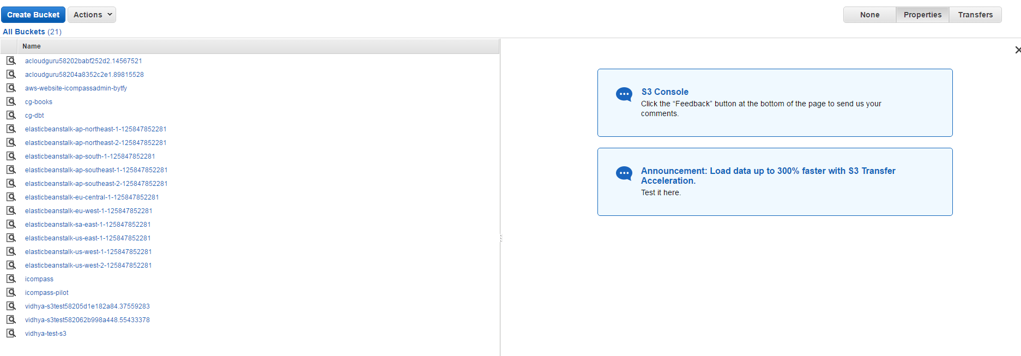

1. **Click Create bucket with the name mytestbucket**

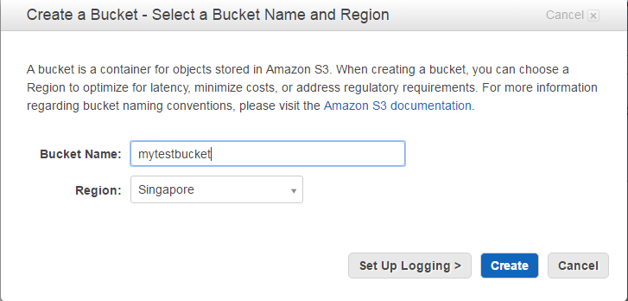

1. **If the bucket already exists we get the message as given below :**

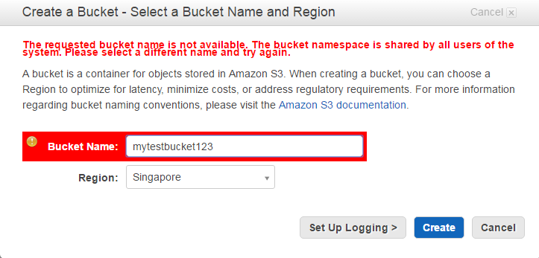

**Create a bucket by name vidhyatestbucket123**

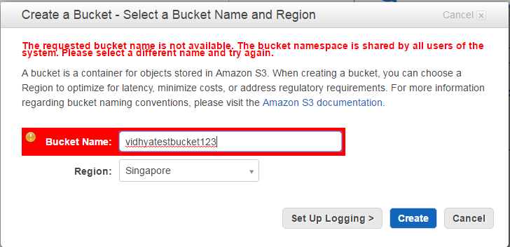

**The bucket is created as shown.**

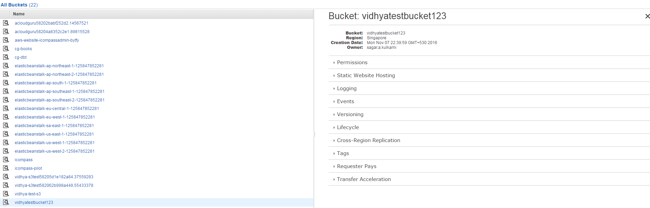

**Click on the bucket vidhyatestbucket123 and upload an image file**

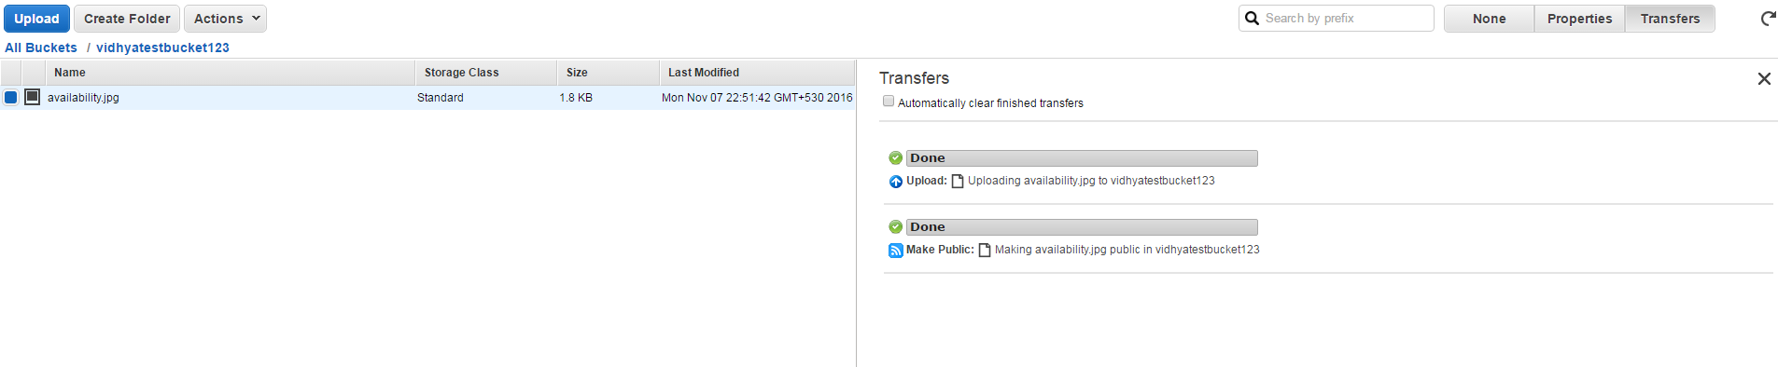

**Click on the URL, it says access denied as shown**.

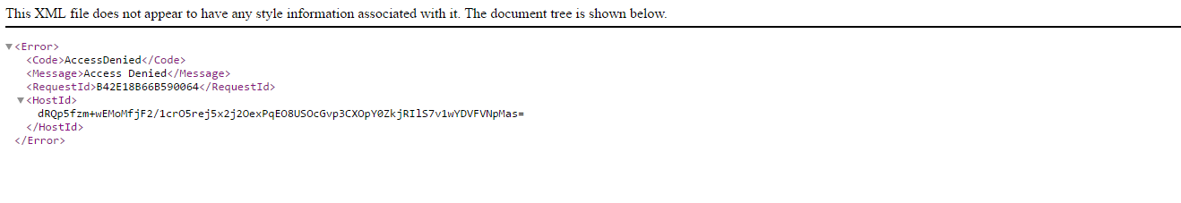

**Grant permissions on the object by select Make Public option from Actions drop down list**

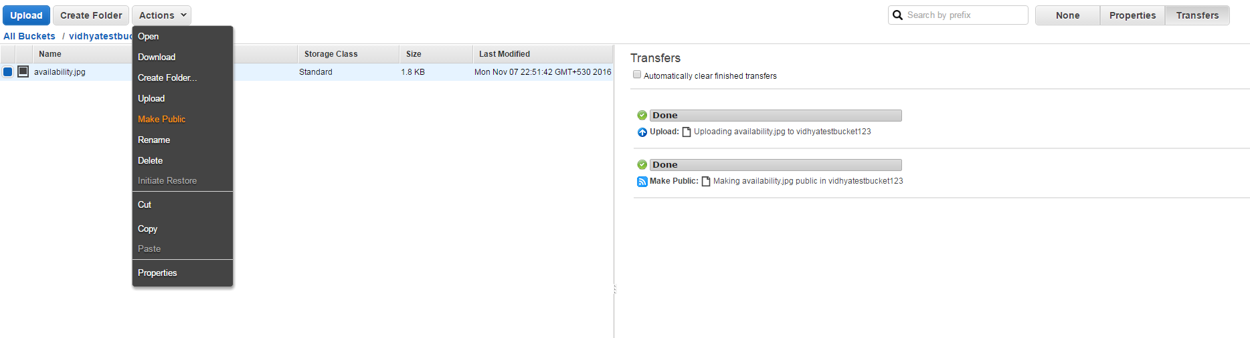

**The other option is to click add permissions -> grantee 🡪everyone-🡪openly download**

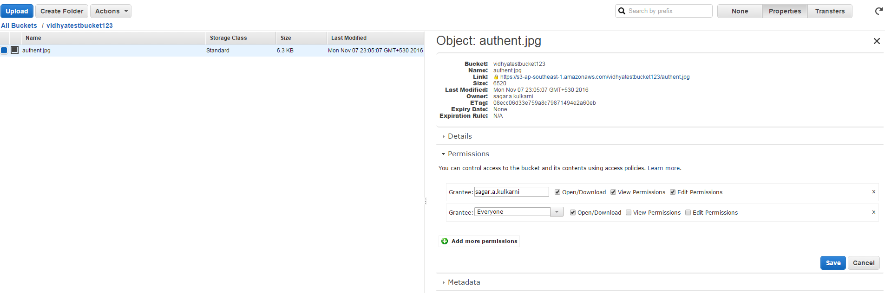

**Choose the object in the bucket and change the storage class as reduced redundancy and Encryption as AES 256**

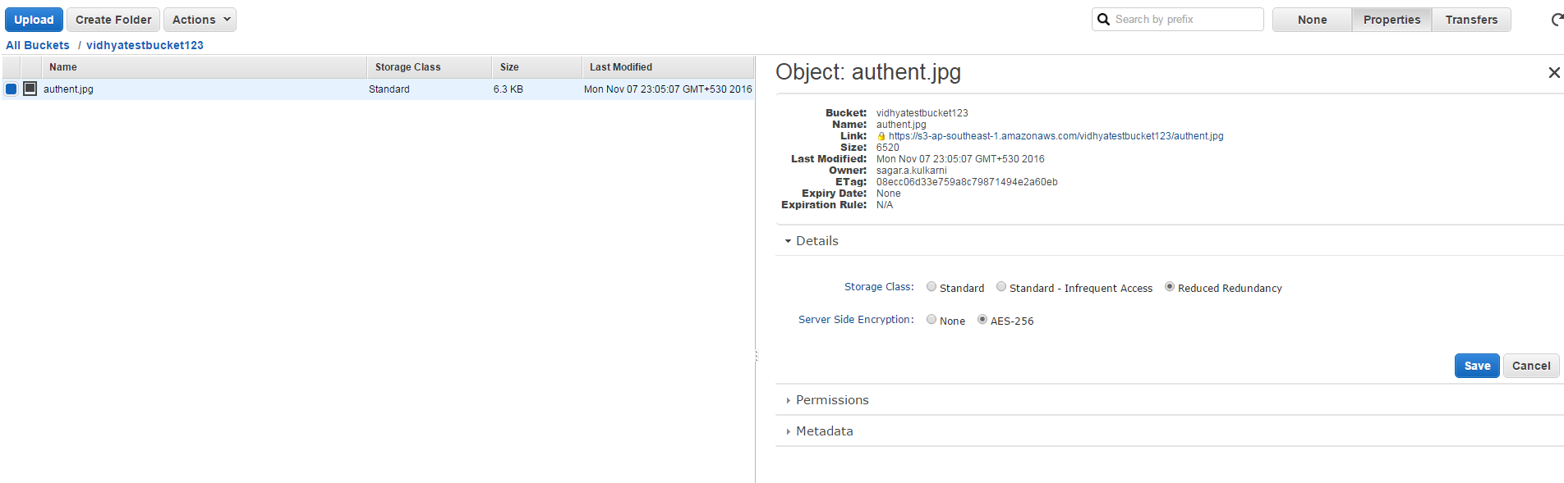

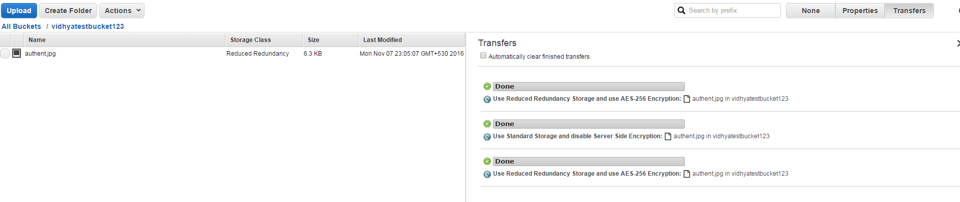

**II .Create a S3 website**

**Open a doc file and type the html code as shown**

**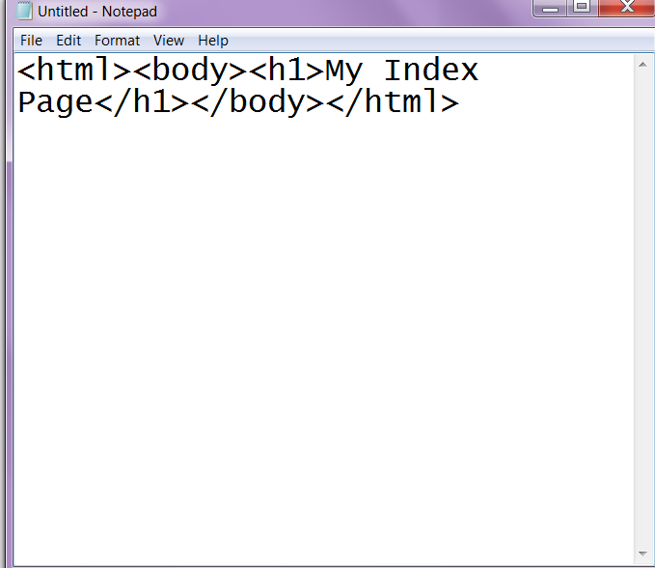**

**Save the file as indexpage.html**

**Also create another doc file with html content and save it as error.html**

**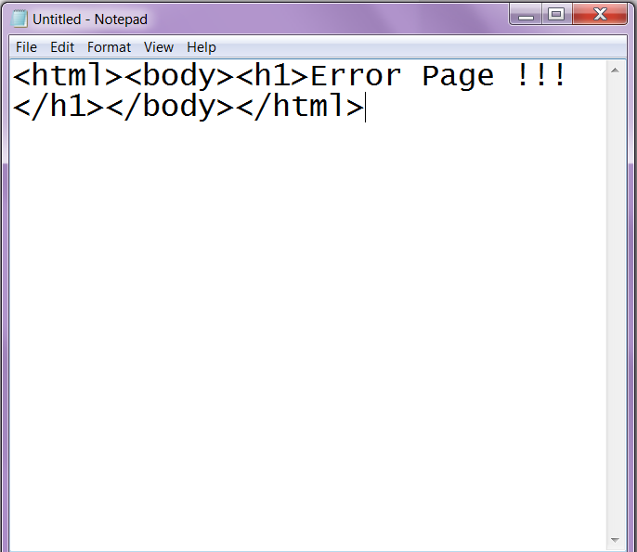**

**Navigate to S3 console in AWS and create a bucket by name testvidhyabucket123 .**

**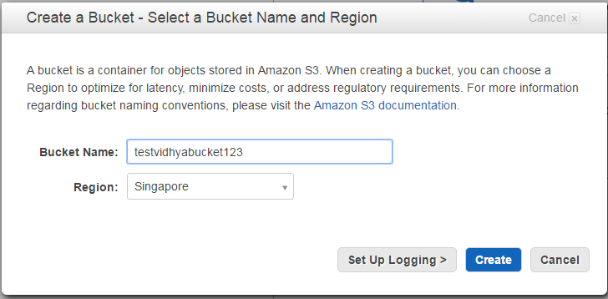**

**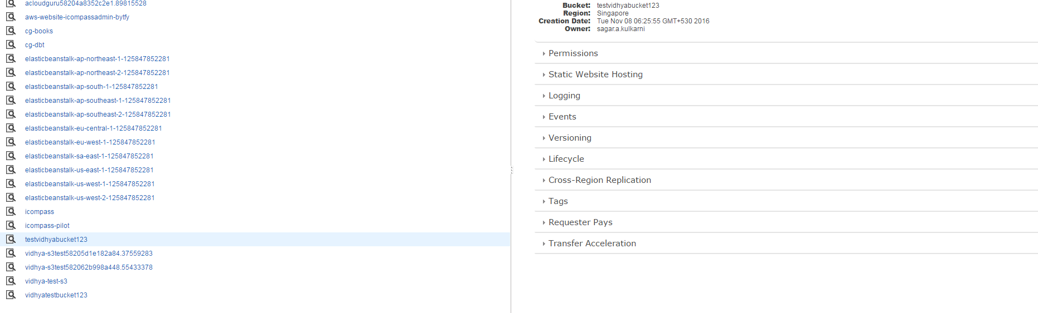**

**Enable the option Enable website hosting under static Website hosting and click save**

**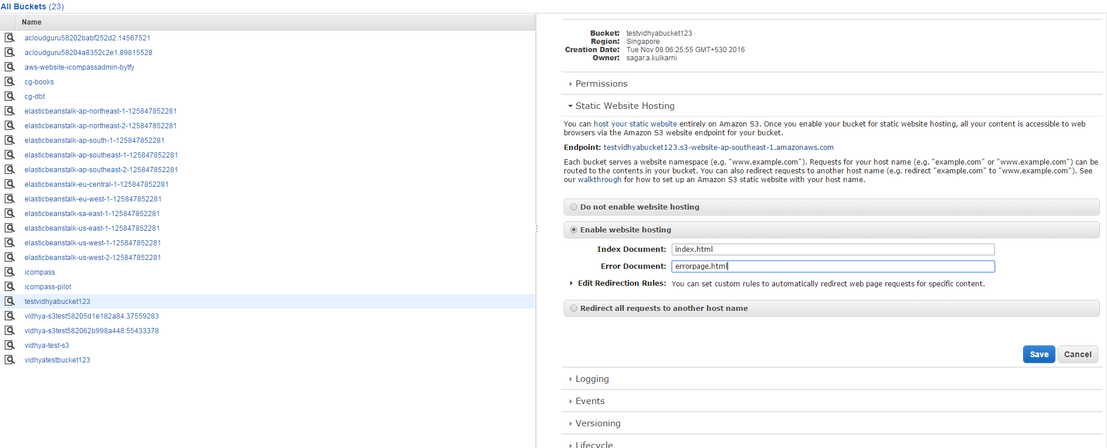**

**Now click the bucket testvidhyabucket123 and upload both the files index.html and error.html**

**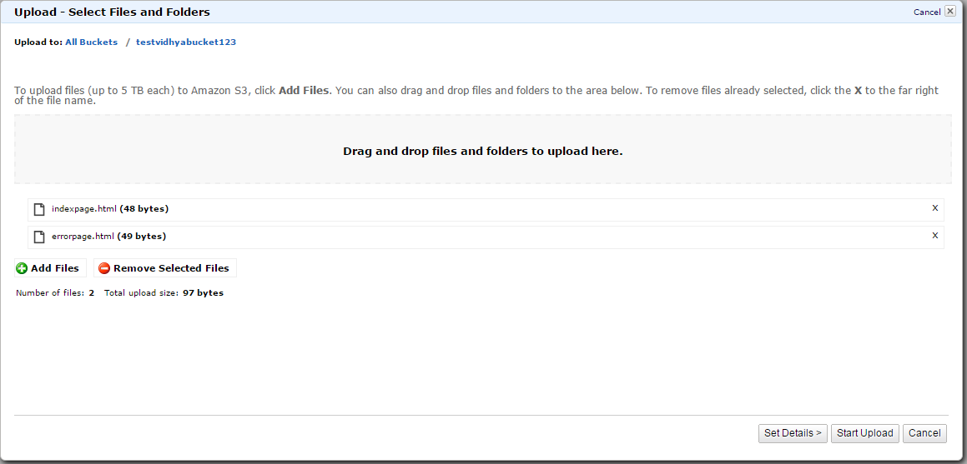**

**Clicks start upload to upload the files.**

**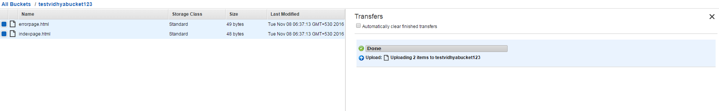**

**Next go to properties -> static website hosting -> click on Endpoint ->** [testvidhyabucket123.s3-website-ap-southeast-1.amazonaws.com](http://testvidhyabucket123.s3-website-ap-southeast-1.amazonaws.com/) . It shows forbidden. By default when we enable static web hosting, it is not made public.

**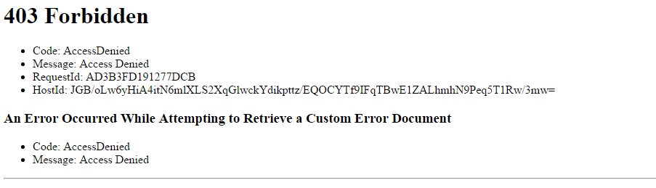**

**To remove this error, choose the files and under Action menu, select Make public.**

**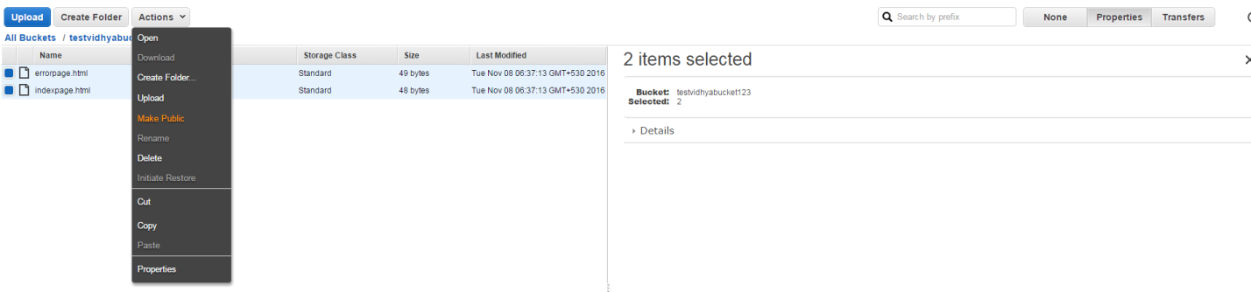**

**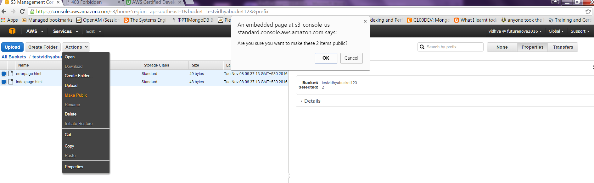**

**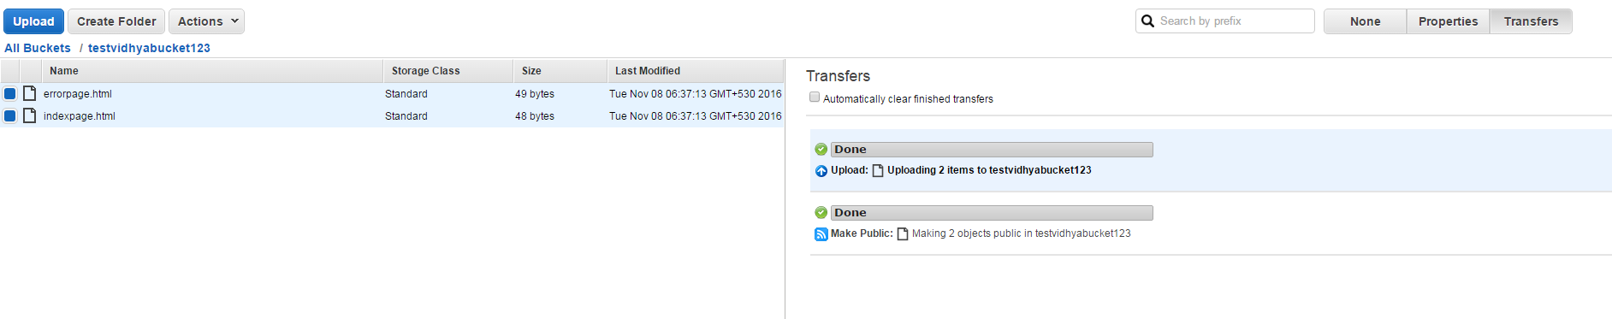**

**Choose index file and click properties and choose Link to see the html page**

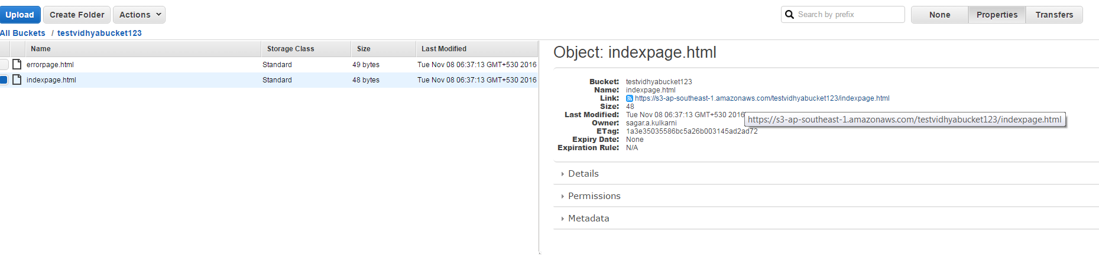

**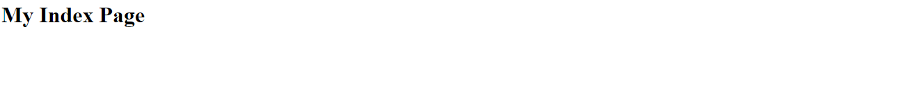**

**Open the browser and copy the endpoint url with /test.php to the see the below page**

**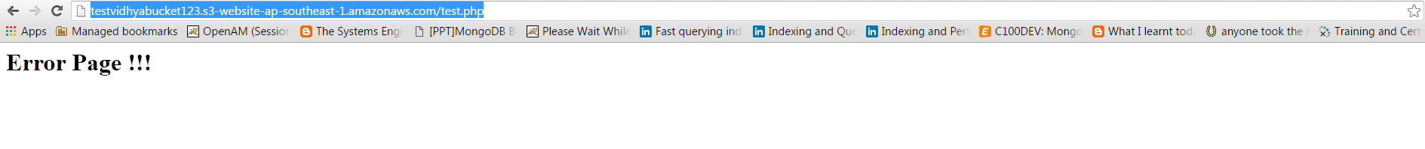**

**3. CROSS Origin Resource Sharing**

1. **Create a new bucket called vidhyanewbucket**

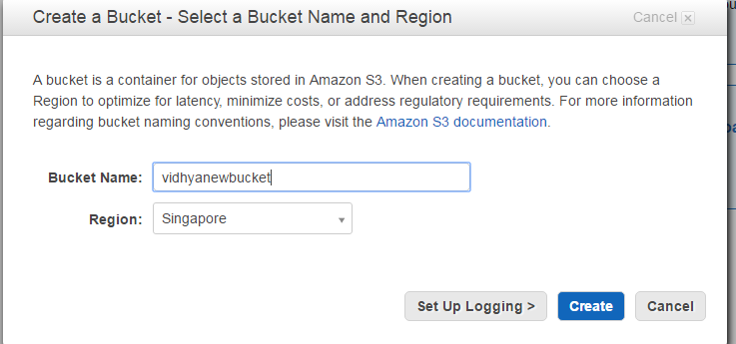

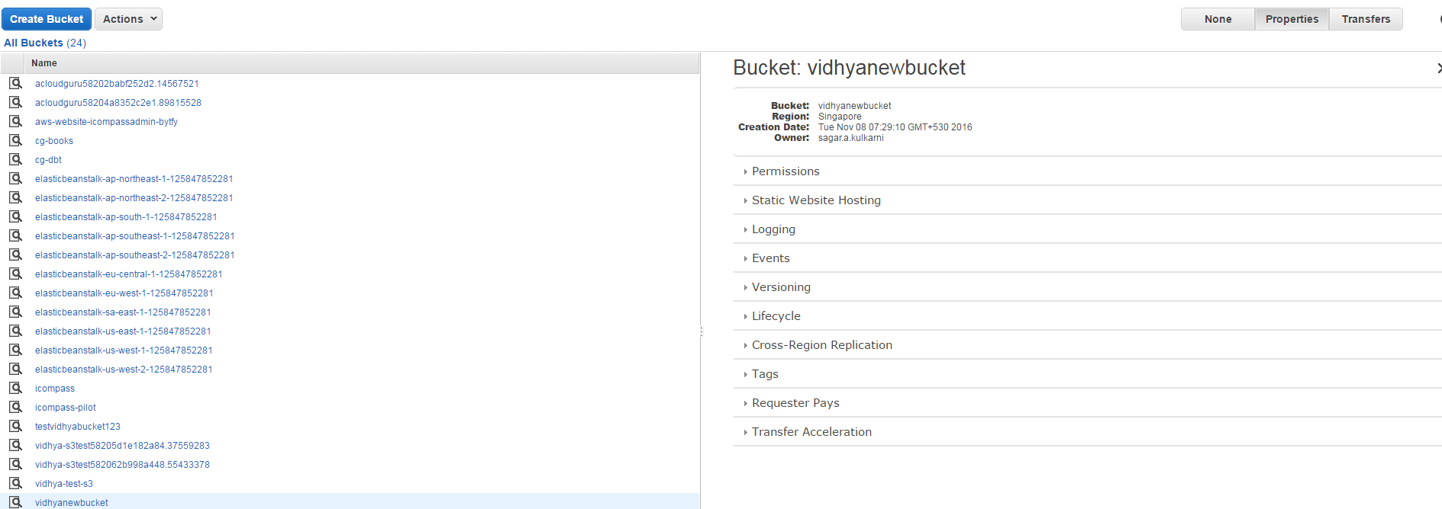

Upload index.html and loadpage.html files

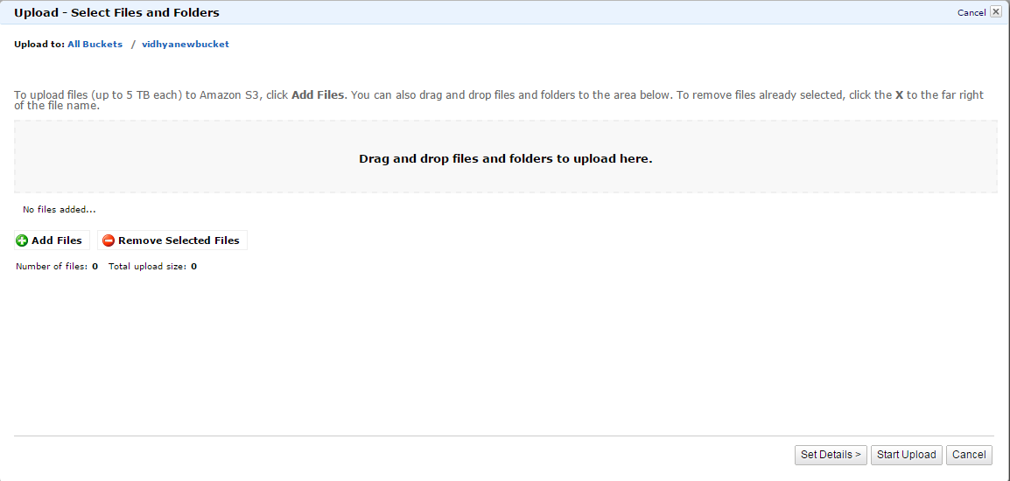

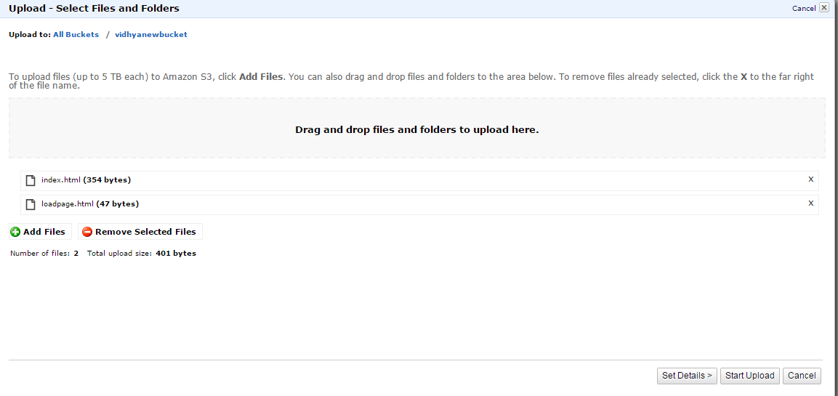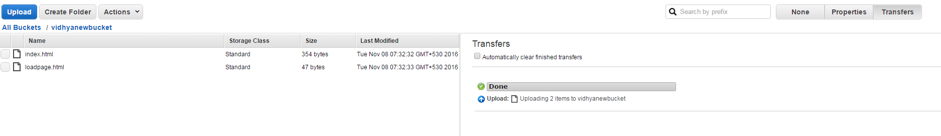

**Enable the option -> Enable website hosting and save it.**

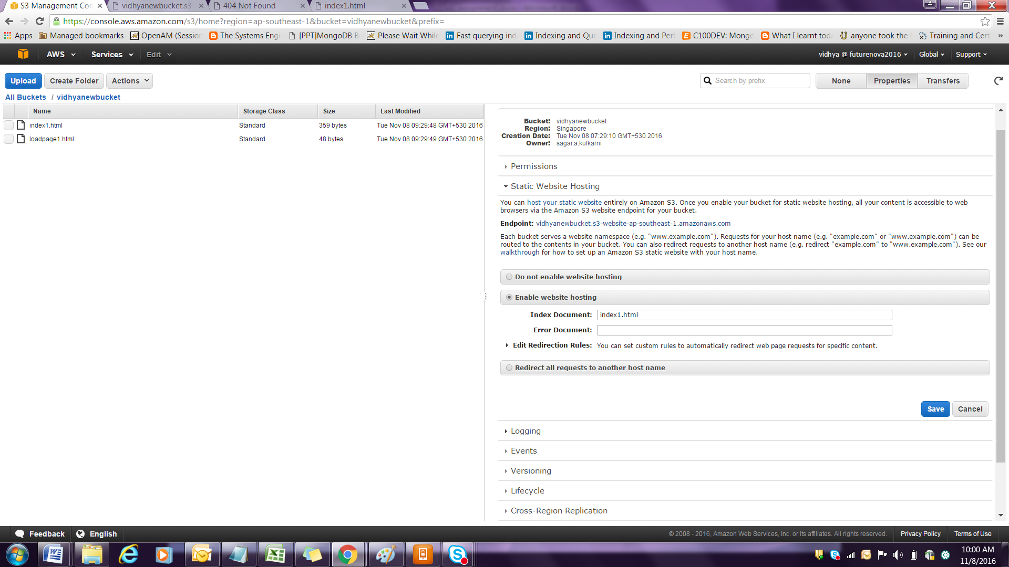

**Open the index.html with additional code as shown**

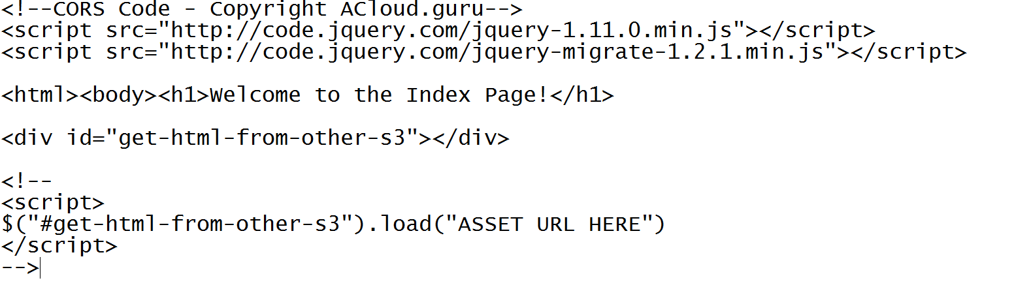

**Replace the line $("#get-html-from-other-s3").load ("loadpage.html") with the one given below and remove the comment line above and below the <script> line ..**

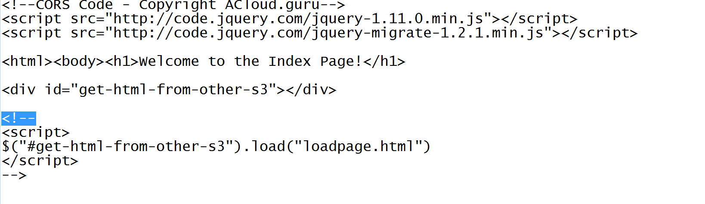

Open the loadpage.html the content is this

|  |
| --- |
|  |
| <h2>Loaded Page Successful!</h2></body></html> |
|  |

Choose the two files and make them public

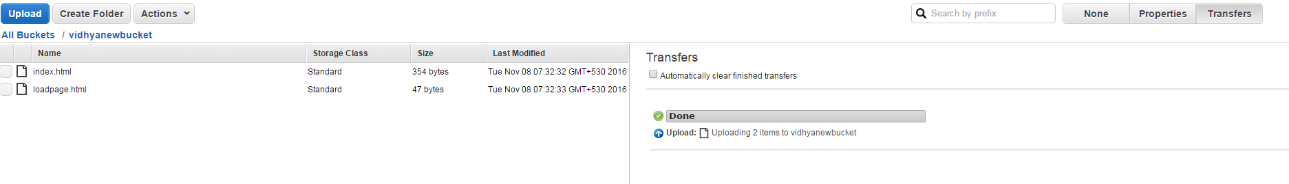

Click on the endpoint in static website hosting

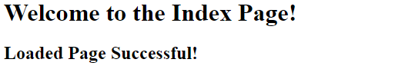

1. **Create a new bucket by name vidhyabucketasset**

**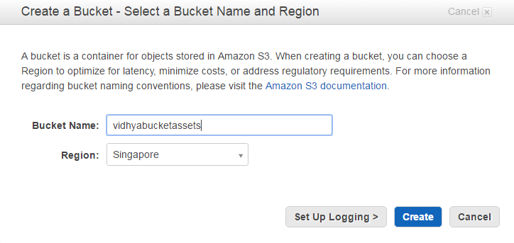**

**Enable the option 🡪Enable website hosting 🡪 mention index1.html and error.html files**

**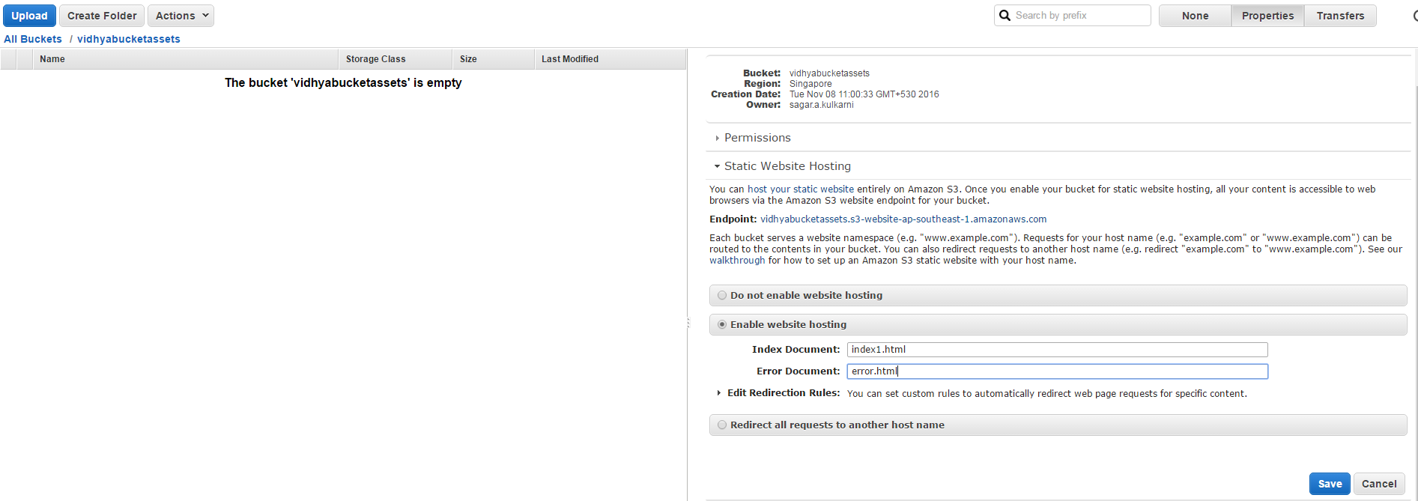**

**Upload the loadpage1.html and make it public**

**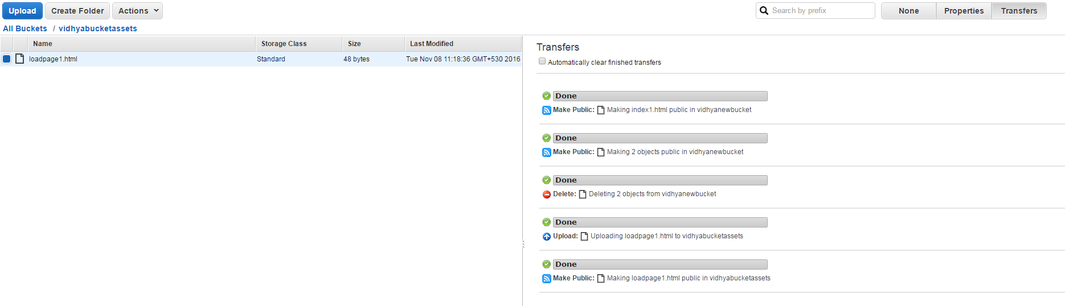**

**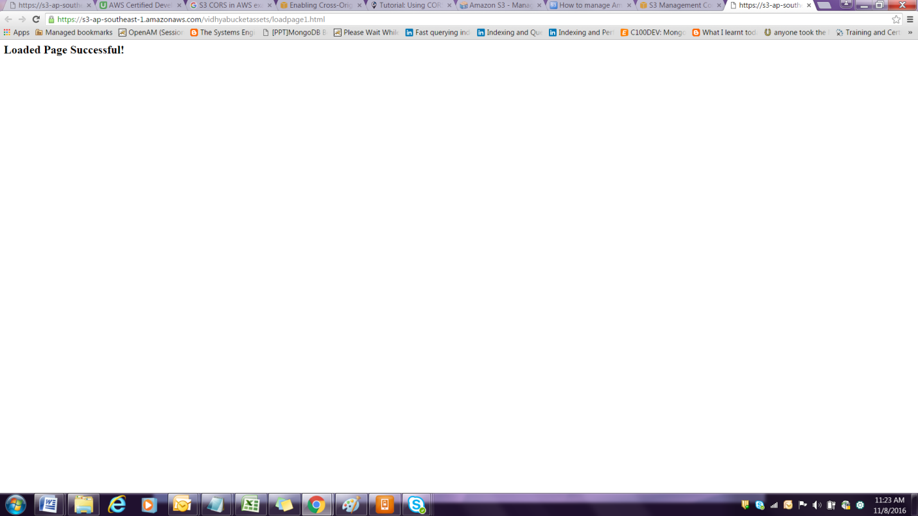**

**Navigate to Static website hosting under the vidhyabucketassets and click on the endpoint**

[vidhyabucketassets.s3-website-ap-southeast-1.amazonaws.com](http://vidhyabucketassets.s3-website-ap-southeast-1.amazonaws.com/)

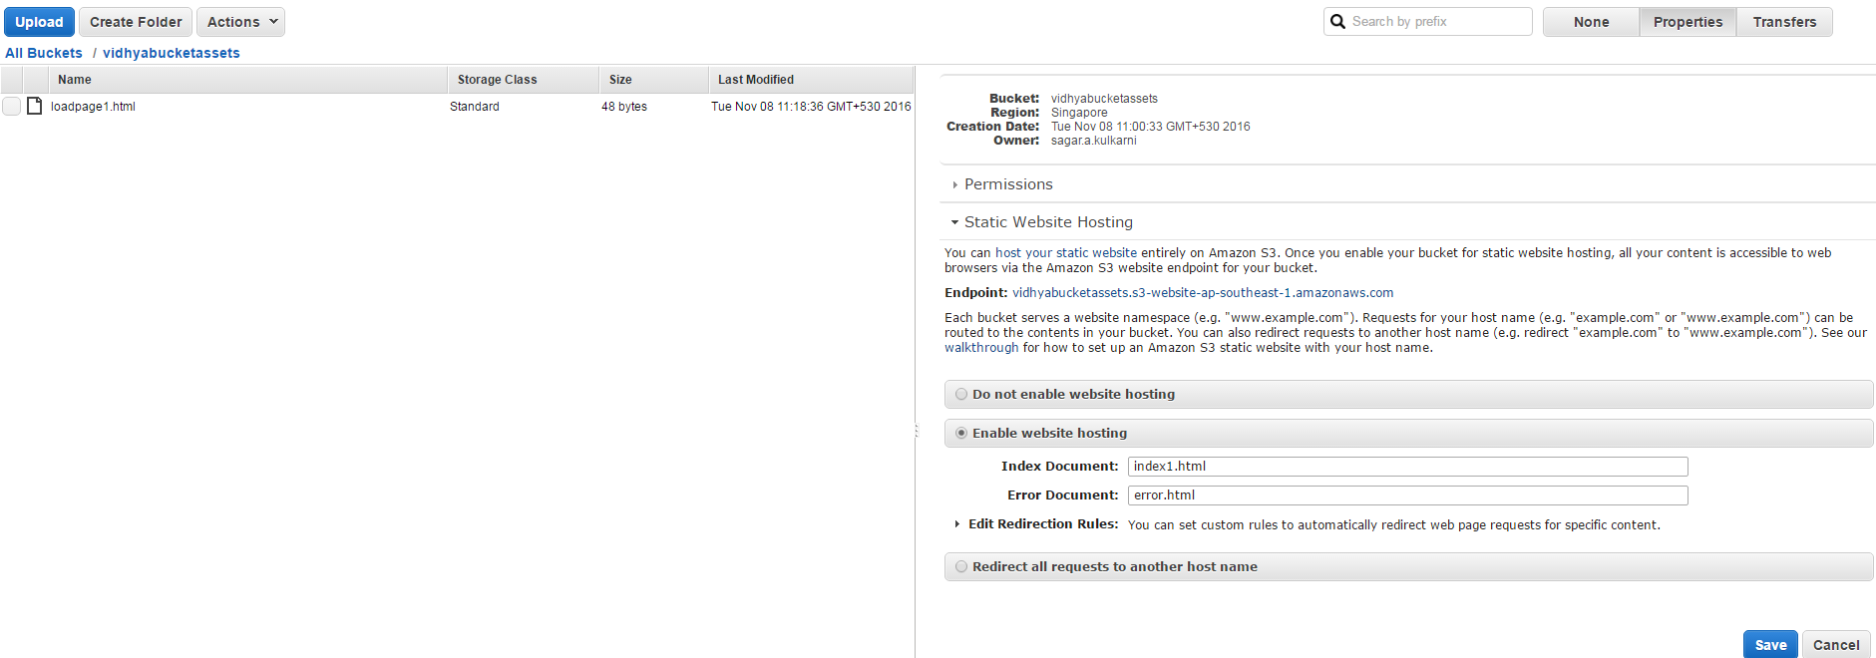

**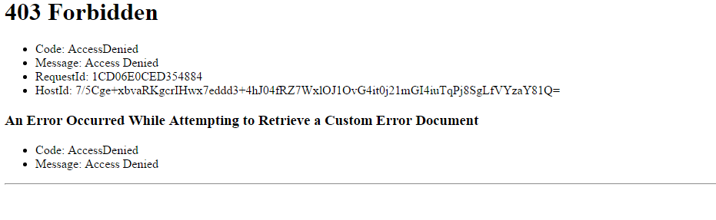**

**Now type loadpage1.html along with the url as shown**

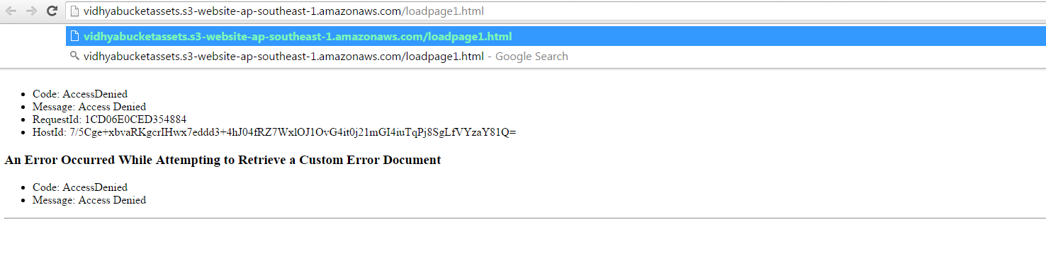

**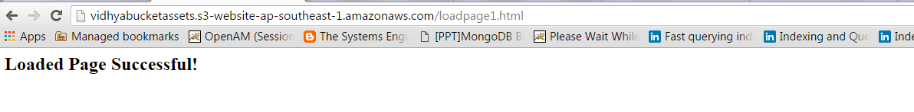**

**Copy the url** [**http://vidhyabucketassets.s3-website-ap-southeast-1.amazonaws.com/loadpage1.html instead of loadpage1.html**](http://vidhyabucketassets.s3-website-ap-southeast-1.amazonaws.com/loadpage1.html%20%20instead%20of%20loadpage1.html)

**And paste it in the index1.html file as given below**

**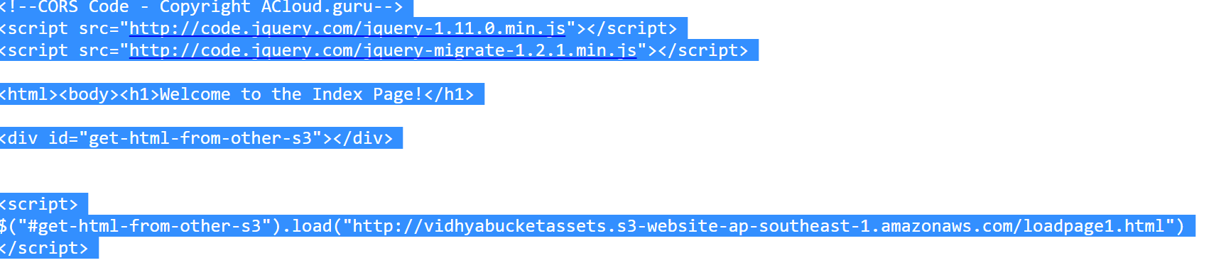**

**Navigate to the bucket name vidhyanewbucket and delete the index.html and upload the file again**

**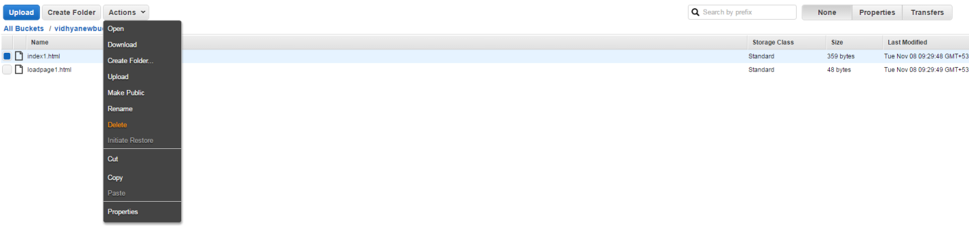**

**Make the index1.html public**

**Go to Properties, static website hosting click on the endpoint or refresh the url <http://vidhyanewbucket.s3-website-ap-southeast-1.amazonaws.com/> to see the page given below**

****

**To allow CORS configuration, navigate to the bucket , remove the loadpage1.html file .**

**Go to properties, copy the endpoint** [vidhyanewbucket.s3-website-ap-southeast-1.amazonaws.com](http://vidhyanewbucket.s3-website-ap-southeast-1.amazonaws.com/" \t "_blank)

In the CORS.xml file ,

**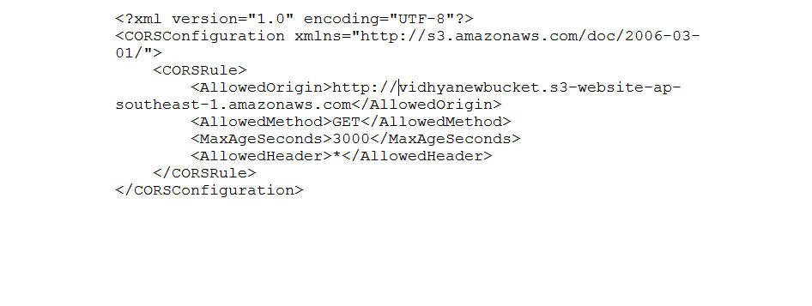**

**Navigate to vidhyabucketassets 🡪 properties ->permissions 🡪 Add CORS configuration**

**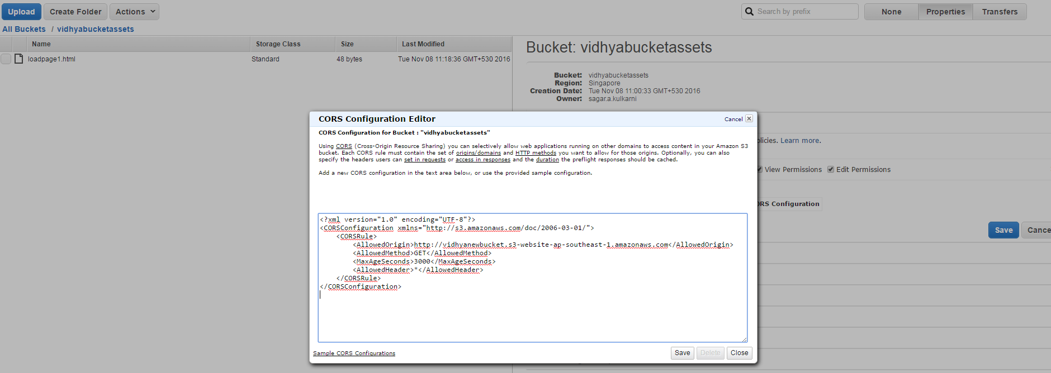**

**Click Save**

**Refresh the link** [**http://vidhyanewbucket.s3-website-ap-southeast-1.amazonaws.com/**](http://vidhyanewbucket.s3-website-ap-southeast-1.amazonaws.com/)

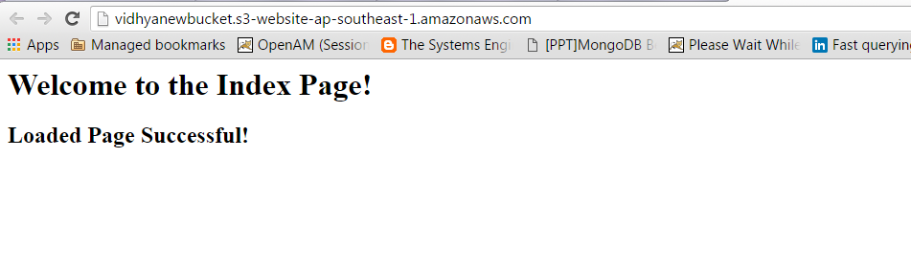

**Versioning**

**Choose a bucket and Enable versioning . Once enabled you cannot disable it . you will have to delete the bucket only.**

**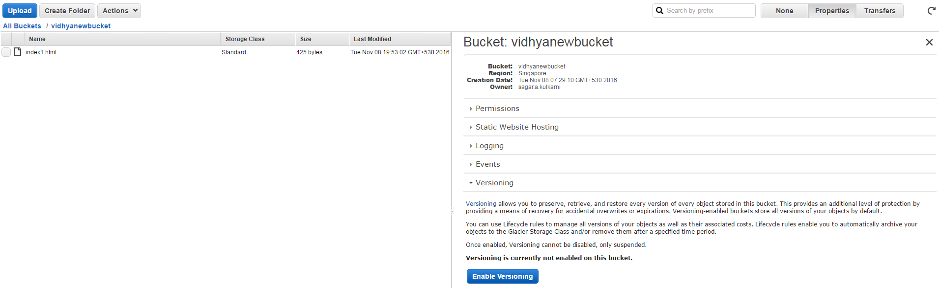**

**In the existing bucket, upload a text file with the content.**

**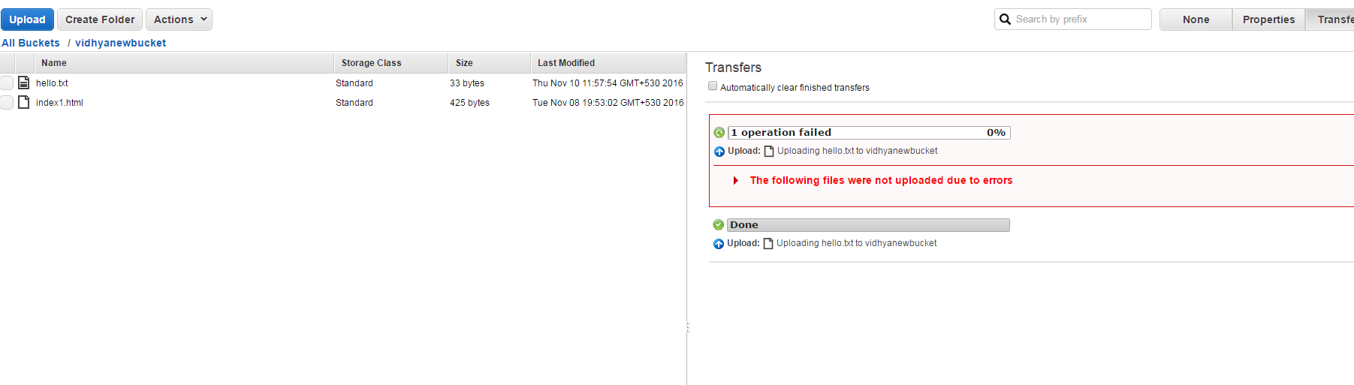**

**Delete the file.**

**Then Click on show to display the different versions of the file .**

**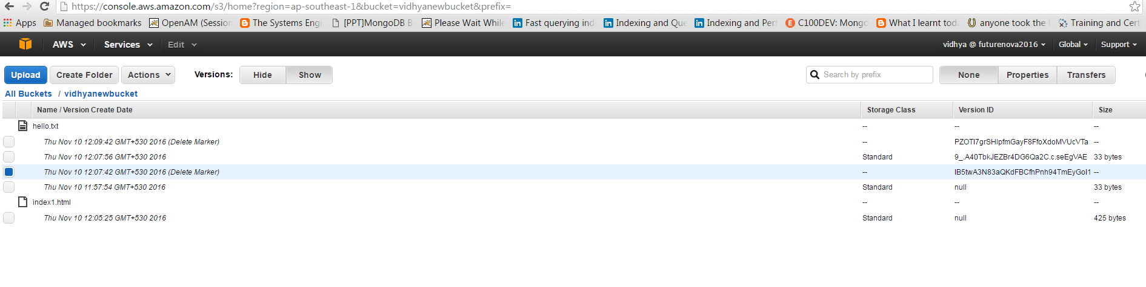**

**Choose the version that have delete marker and delete them .**

**Click hide and you can see the original file being restored .**

**Do some updates in the file and upload the file again .**

**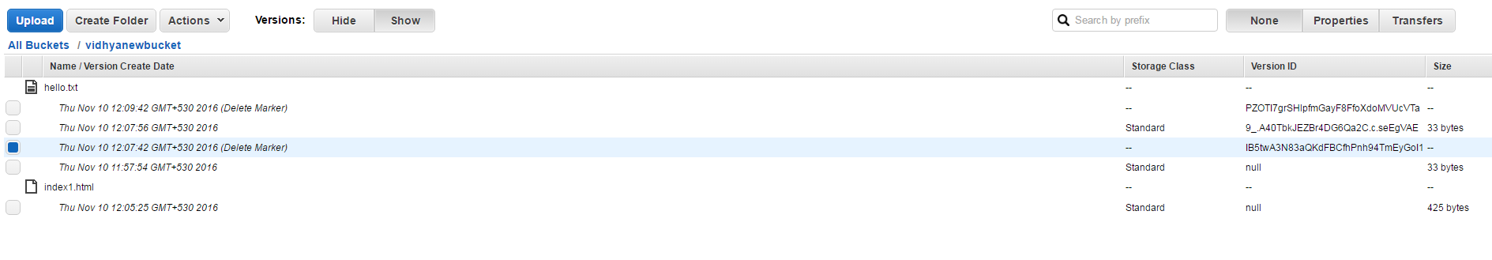**

**You can see different version of the file . If you want to retain the versions you can ,else you can delete which ever version you want .**

**CROSS Region Replication**

**Enable the Cross region replication**

**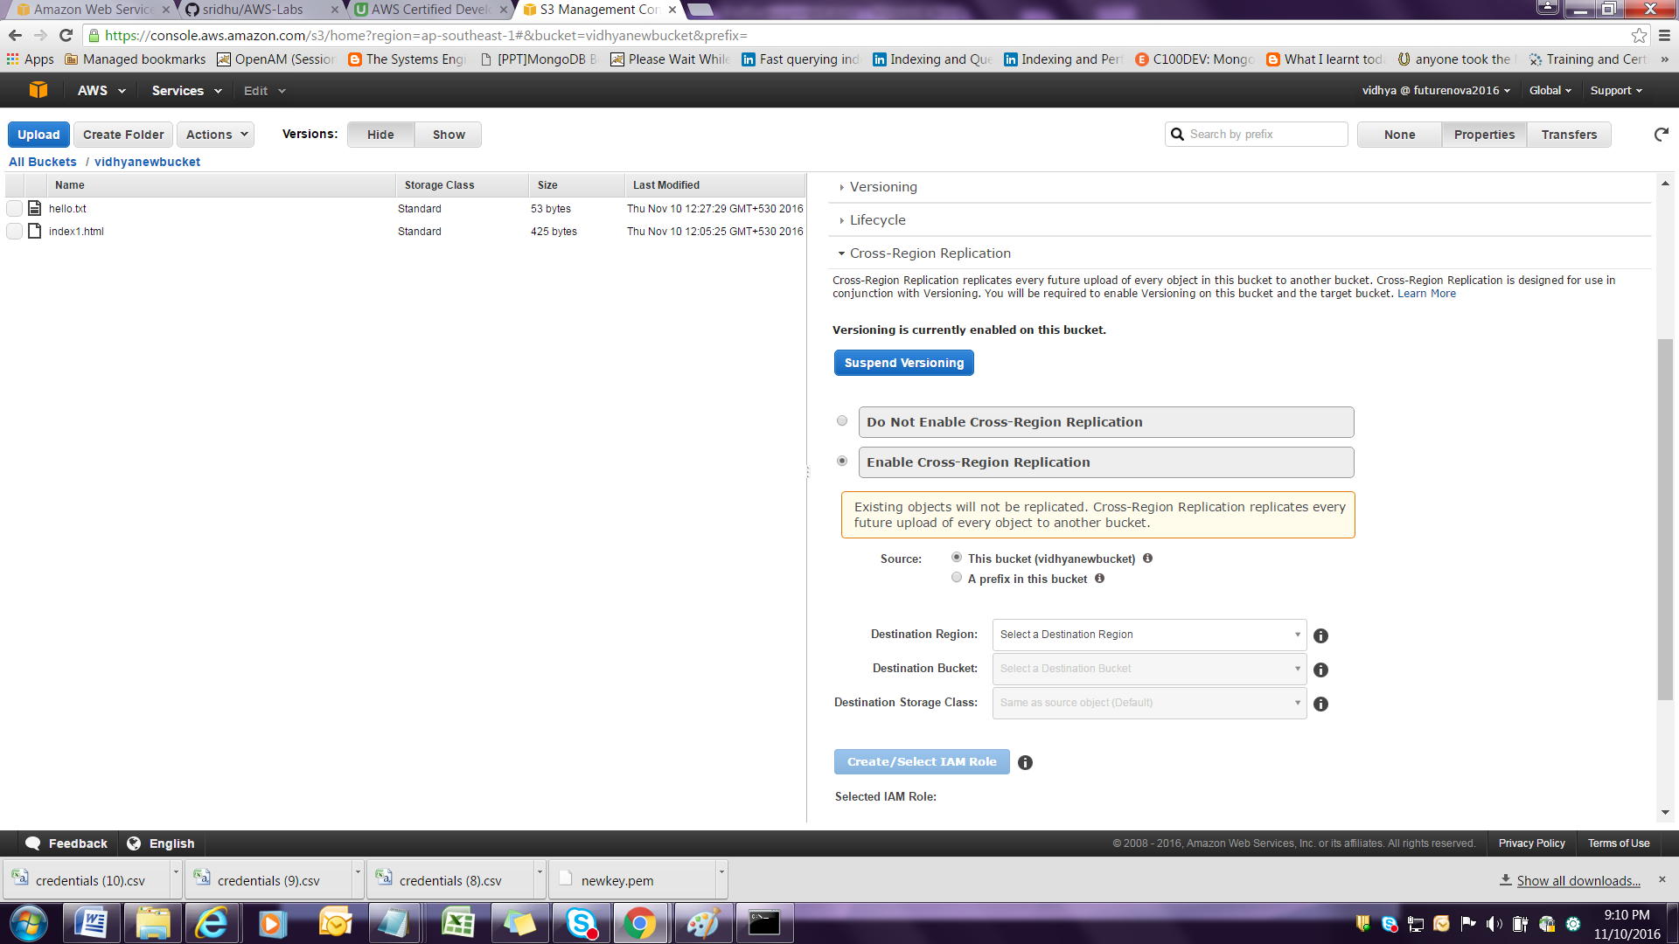**

**Choose the option Destination bucket, Destination Region, Destination Storage class.**

**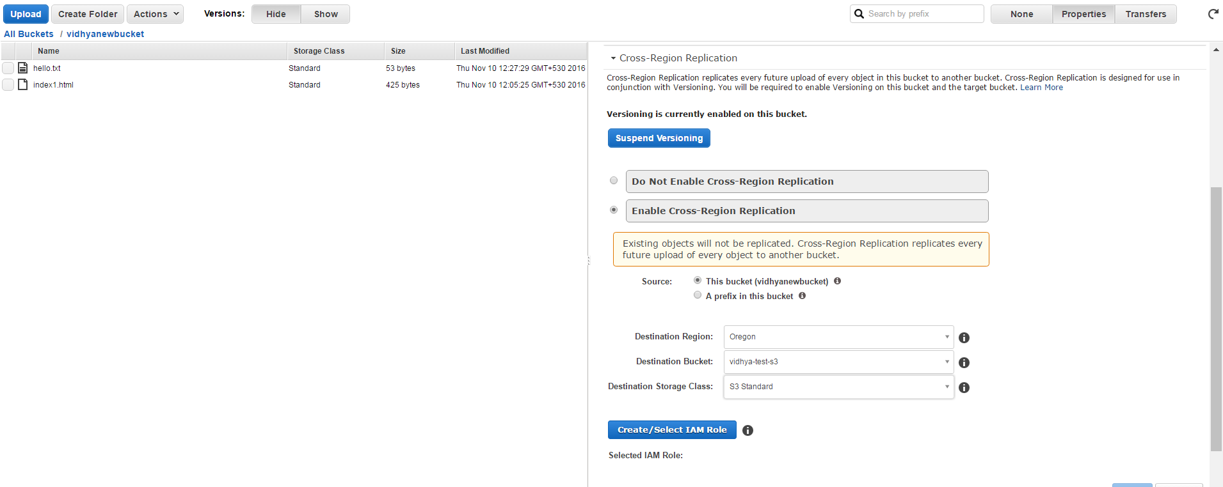**

**Select IAM role.**

**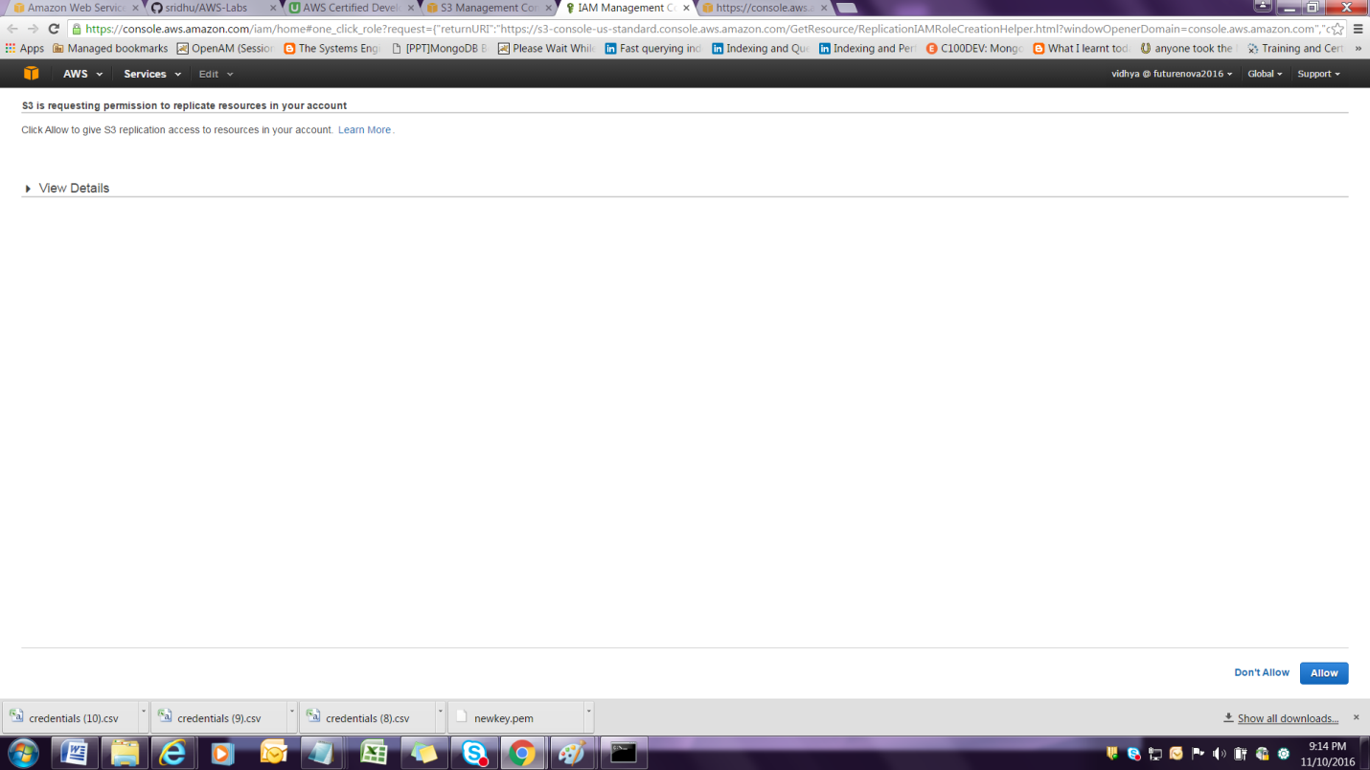**

**Select IAM role and click Allow**

**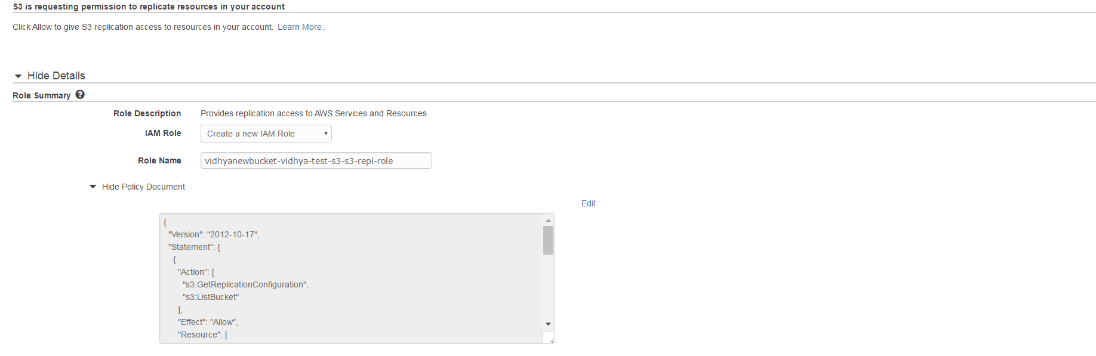**

**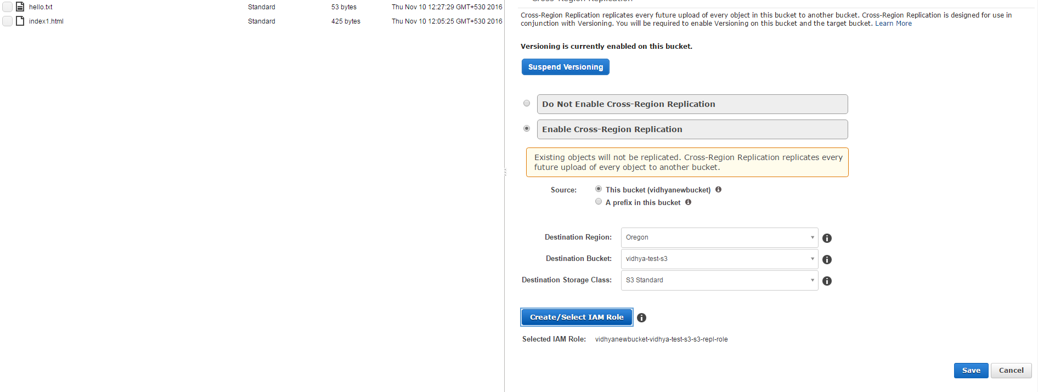**

**Click Save .**

**Versioning must be enabled at the destination bucket as well.**

**Once Cross region replication is enabled, future uploads of files get replicated.**

**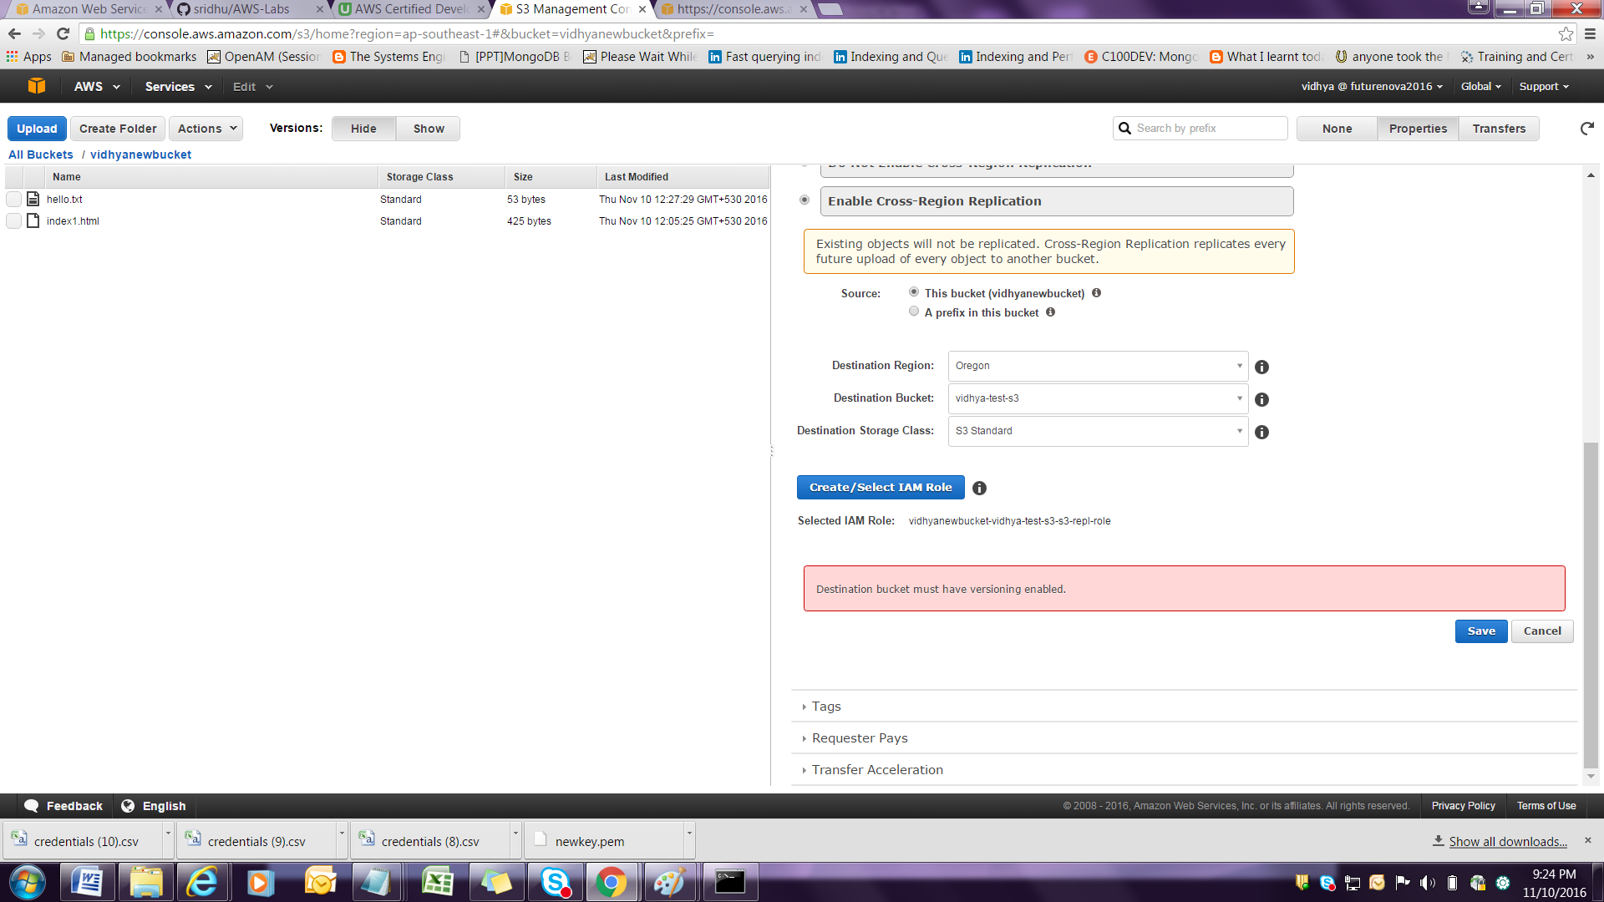**

**Modify the file with the content and upload it again**

**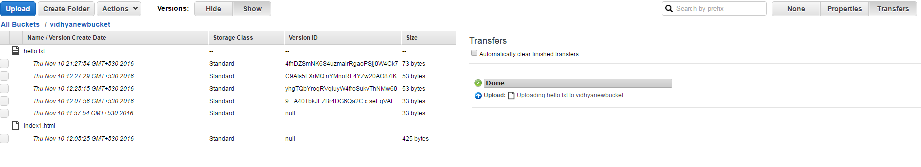**

**Here in test33hello the versioning is enabled and that is the destination bucket .**

****